A parent’s guide to 

This year Samuel Ward Academy has continued to subscribe to Tassomai (<https://www.tassomai.com>), an online learning tool which uses an algorithm to adapt the quizzes it delivers to your child’s previous responses.

In Science we are continuing to set students 4 daily goals each week as part of their Science homework for all Y7-11 students. The daily goal requires them to reach a certain number of points - they get points for getting questions correct but will lose points if they get them wrong – this reduces the amount of random guessing on these multiple-choice questions. At the end of the Quiz your child may be given links to videos/revision guides to allow them to close the gaps that have been identified.

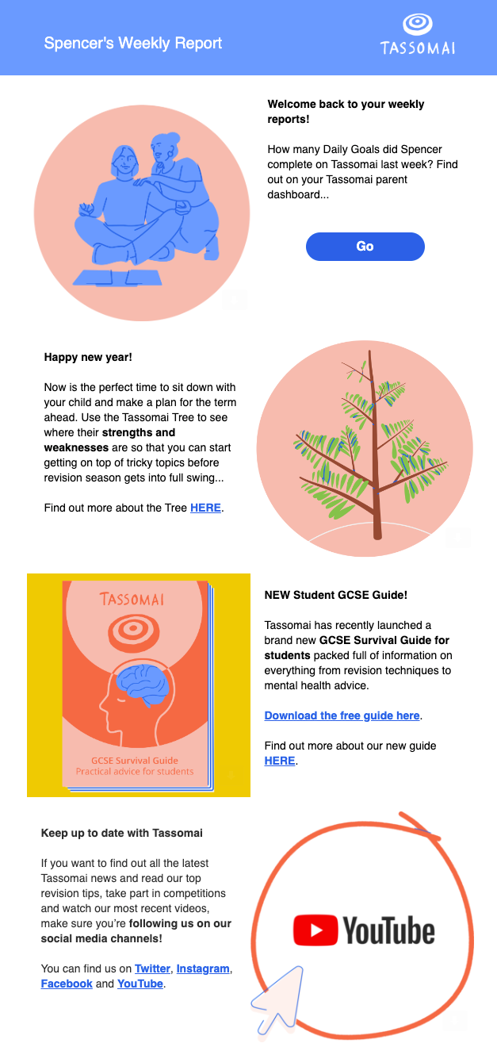As part of our school’s subscription, you can receive a weekly email with a report of how your child is doing on the program. This report can be sent every Monday morning and will break down your child’s usage and performance from the previous week. Their strongest topics will be identified, as well as those areas that they require more support with. You will also be given statistics on their average accuracy and how many days they have been active on the program.

The weekly Tassomai report also gives you instructions on how to log in to your own account, giving you access to your child’s Tassomai Tree - an interactive visual that shows your child's growth in their subjects. Selecting red and orange leaves on the tree will bring up the material your child is currently having difficulties with. If you have more than one child using Tasso mai at our school, don’t worry! You can easily switch between them from your own account.

For more information see: <https://www.tassomai.com/school-parent-info>